Computer Language Diagrams

Dual & Unary in a Diagram
The concept of dual and unary is explained in the articles Dual & Unary, Related Classes and Relations.
The expression of dual and unary in a diagram has already been introduced in the articles Related Classes in a Diagram and Relations in a Diagram. This article only puts the diagram expressions of dual and unary next eachother for a comparison.

This is a unary relation between Class A and Class B:

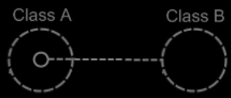

This is a dual relation between Class A and Class B:

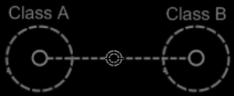

See also: Dual & Unary, Related Classes, Relations, Related Classes in a Diagram, Relations in a Diagram

Author & Copyright: Jan-Joost van Zon Date: June 2, 2008 – June 2, 2008 Location: Oosterhout, The Netherlands Status: Finished

